Topics for the «StudentDigitalFest» contest - 2021

- Automation of calculations of pollutants emissions, greenhouse gases and energy efficiency.

This system will be used to calculate pollutants emissions, greenhouse gases (GHG) and energy efficiency of significant equipment and the enterprise in general.
The data on the consumption of fuel gas, diesel, gasoline, electricity, combustion of raw gas (7 types), operating hours of equipment, composition of gas and liquid hydrocarbons, production of products (electricity, gas, oil, steam, etc.) will be input into system. Further, calculations will be carried out according to the method for GHG and pollutants calculation, the method of energy analysis and graphs will be created.
It is necessary to enable the option to export data in excel and add new data that may be useful in future.

Objective (what for?)
Increase efficiency, eliminate unnecessary paperwork and speed up reports preparation;

Information to be provided (which docs/info?)
The information on the enterprise in general will be presented, as well as on significant equipment - a gas turbine power plant (GTPP), gas turbines of gas re-injection compressors and a high-pressure boiler.

The following data is required for gas turbines of gas re-injection compressors:
- Gas consumption volume, thousand m3;
- Injected gas volume, thousand m3;
- Operating time, hours;
- Gas composition, weight%;
- Results of measurements of waste gases, g/s.

The following data is required for GTPP:
- Gas consumption volume, thousand m3;
- Generated electricity, MW*h;
- Operating time, hours;
- Gas composition, weight%;
- Results of measurements of waste gases, g/s.
- Actual capacity, MW.

The following data is required for high pressure boilers:

- Gas consumption volume, thousand m3;
- Steam volume, t;
- Operating time, hours;
- Gas composition, weight%;
- Results of measurements of waste gases, g/s.
- Superheated steam enthalpy, kJ/kg;
- Feed water enthalpy, kJ/kg;
- FG lower heat combustion, kJ/m3;
- FG lower heat combustion under normal conditions, kJ/m3.

Output (what is expected?)
It is expected to receive an automated system for calculating emissions of pollutants, greenhouse gases and energy efficiency, which will speed up the reporting process and simplify the company's document workflow.

- Implementation of a Remote Well Surface Pressure Monitoring system to improve and optimize Well Integrity surveillance.

Brief description of the problem that needs to be solved/mitigated with digitalization
- Wells during their life needs to be continuously monitored.
- Difficulty to reach remote location.
- Well monitoring requires personnel travels with car to well location with associated transport risk.
- Risk of data gaps that could compromise Well Integrity surveillance.

Objective (what for?)
Well monitoring is a fundamental topic of Well Integrity activities. Equipment with related App which can be installed on well site to provide continuous pressure reading, pressure trend and temperature from the Well at surface (Tubing Head and Annulus). The analog signals are modulated as digital signals by data acquisition system; the digital signals are then transmitted to database server of monitoring center.

Information to be provided (which docs/info?)
Will be defined.

Output (what is expected?)
- To have continuous monitoring of Well surface parameters, also on remote Well location.
- To minimize data gaps.
- To have more reliable data by minimizing human error during physical monitoring.
- To gain greater leverage from field personnel by monitoring and controlling more locations at same time.
- To decrease car incident exposure with less driving hours.
- To minimize transportation costs.
- To decrease risk of people injuring.

- Develop a search engine based on pattern recognition to scan and detect indicated symbols on engineering drawings
The search engine will be used to scan large amounts (100+) of uploaded engineering drawings in pdf format to detect and highlight symbols, indicated by the user. The drawings containing the sought symbol will be further sorted from the rest, and will have the symbols highlighted for easier visual identification by the user.
Objective (for what?)
The software will allow for significant time-savings by performing repetative searches of indicated equipment symbols, allowing engineers to focus on further analysi
Information to be provided (which docs/info?)
Sample engineering drawings (Piping and Instrumentation Diagrams, P&IDs, standard equipment symbol legend)
Output (what is expected?)
A simple and intuitive graphical user interface, with a prompt window to upload files to be analyzed and a second prompt to upload a jpeg image of the sought symbol. Output window with files that contain the identified highlighted symbols.
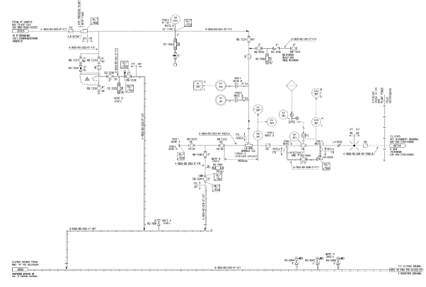
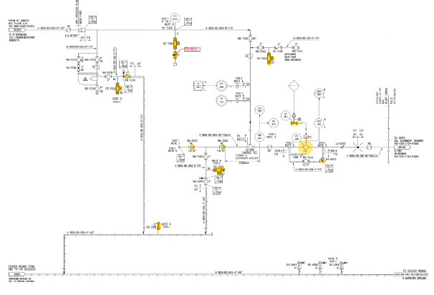
Sorted files with symbols higlighted
Search for symbol
Uploaded documents

